ASSIGNMENT – 3
1. Print Star Pattern
n = 5
for i in range(n):
print("*")
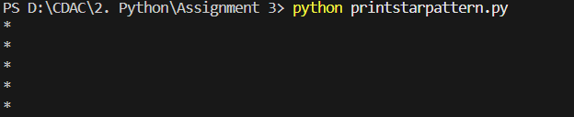
2. Horizontal Star Pattern
n = 5
for i in range(n):
print("*", end="")
3. Right Triangle Pattern
n = 5

for i in range(n):
for j in range(i + 1):
print("*", end="")
print()
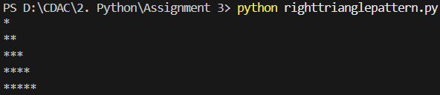
4. Inverted Right Triangle
n = 5
for i in range (n +1):
for j in range(i, n):
print("*", end="")
print()
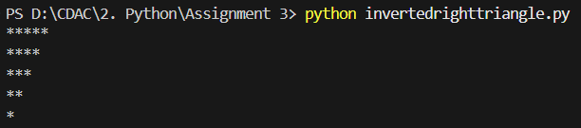
5. Number Triangle
n =5
for i in range (n):
for j in range(i + 1):
print(j + 1, end="")
print()
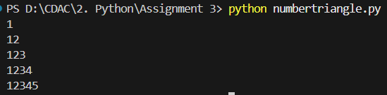
6. Repeated Number Pattern
n = 5
for i in range (n):
for j in range(i + 1):
print(i + 1, end="")
print()
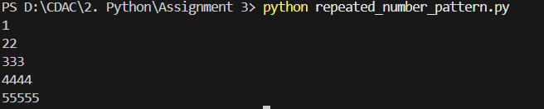
7. Alphabet Triangle

